PUBLICATION PREPARATION guideline
Name1 Surname1 ^{1,*}, Name2 Surname2 ²
¹Department of Mathematics, Czestochowa University of Technology,
Czestochowa, Poland
²Department xxxxx, University xxxxx,
Warszawa, Poland
¹name1.surname1@server1.pl, ²name2.surname2@server2.pl
Received: Day Month Year; Accepted: Day Month Year
Abstract. This article is to be prepared in English language. The abstract precedes content of the work (capacity 7 to 10 verses). Required shape of the article can be easily achieved by overwriting ones text with the text of the hereby guideline, using defined styles. The article, the licence and the declaration should be sent by the JAMCM Editorial System: http://jamcm.pcz.pl/system/ . Contact to the Editorial Board by e-mail: jamcm@pcz.pl .

MSC 2010: 00X00, 00Y00 (see: http://www.ams.org/msc/msc2010.html )
Keywords: mathematics, computational mechanics
1. Introduction
Text of the work should be prepared in the Microsoft Word editor for Windows or in LaTeX. Even page number of the article is preferred. The Microsoft Word and LaTeX templates are available for download at http://amcm.pcz.pl/?id=for_authors.
Margins on the A4 sheet: top – 3.6 cm, bottom – 6.4 cm, left , right – 4 cm. Title of the article: Times New Roman 12 pt, bold italics, centred, space 12 pt above and 36 pt below the title (style: JAMCM_title). Name and surname of the author (authors): Times New Roman 10 pt, bold italics, centred (style: JAMCM_author). The affiliation (university, e-mail): Times New Roman 9 pt, italics, centred, space 6 pt above and 20 pt below the affiliation (style: JAMCM_affil). Abstract of the article (Abstract): Times New Roman 10 pt, text justified on both sides (styl: JAMCM_abstract). Text: Times New Roman 11 pt, text justified on both sides, space between verses: singular, beginning of a paragraph: indenting 5 mm (style: JAMCM_text).
2. Titles of chapters
Caption (title of the chapter): Times New Roman 12 pt, bold font, left-aligned; spaces 22 pt above and 12 pt below the caption (style: JAMCM_section), first caption: space 36 pt above and 12 pt below the caption (style: JAMCM_section1).
2.1. Subheading
Subheading: Times New Roman 11 pt, bold; left- aligned; spaces 24 pt above and 12 pt below the subheading (style: JAMCM_subsection).
2.2. Page headers
Headers should include name and surname initials of authors on even pages, and an appropriate expression regarding the content of the article on odd pages (e.g. full or part of the title of the article). On the first page: title of the journal.
3. Mathematical formulas
Formulas, e.g. (5), should be created with “Microsoft’s” equation editor or other compatible editor, leaving 9 pt spacing before and after it (style JAMCM_eqn). Formulas and symbols: italics; matrices and vectors: bold; formula numbering on the right side, continuous numeration within the article.
(5)
or
(6)
Font size within formulas: Basic (Normal): 11 pt, Subscript/superscript: 7 pt, Inferior subscript/superscript: 6 pt, Symbol: 17 pt, Sub-symbol: 11 pt. Meaning of used symbols in the equation is to be described.
4. Tables and figures
Tables and figures are to be included in a file with the text of the work (they should be an integral part of the work). All illustrations should be legible with uniform and comprehensive designations.
Table titles are to be place above the table, font Times New Roman 9 pt (style: JAMCM_table_caption). Text in tables: Times New Roman 9 pt, centred (style: JAMCM_table). Tables’ width cannot exceed 13 cm.
Table 1. Number of Mathematics students in particular years
 | 1st Year | 2nd Year | 3rd Year | 4th Year
Women | 16 | 15 | 22 | 12
Men | 12 | 14 | 12 | 8

Figures and graphs may be created with a discretionary technique in order to provide a legible black and white printout.
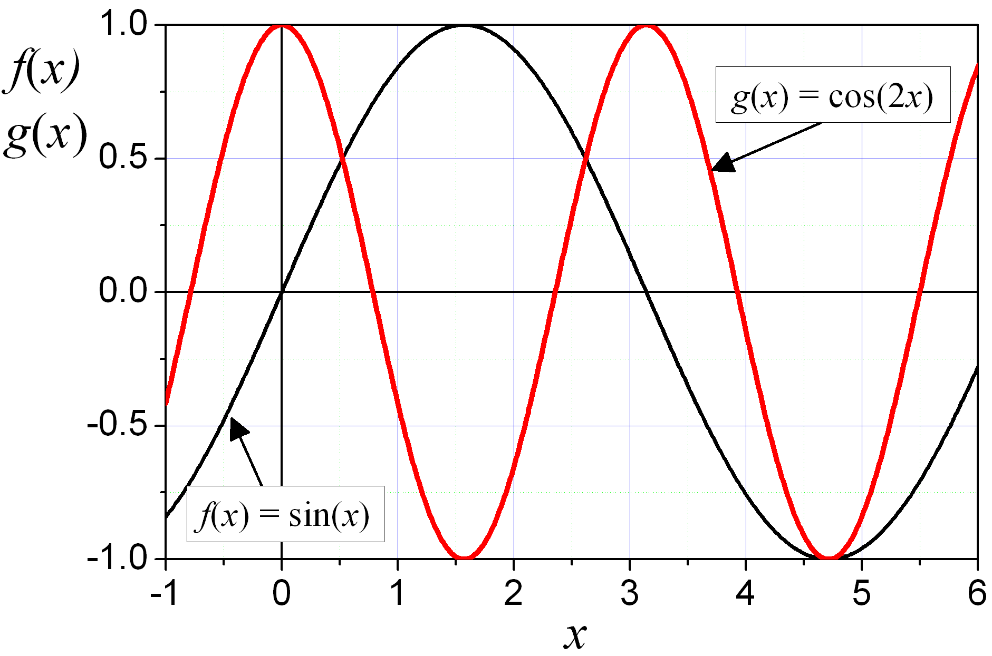
Fig. 1. Graph of a function f(x) = sin(x) and g(x) = cos(2 x)
Description of figures: Times New Roman 9 pt, centred, spaces 5 pt above and 14 pt below the figure’s designation (style: JAMCM_fig), figures’ width cannot exceed 13 cm.
5. Additional information
Submission of papers: Two printed copies and a soft copy with all figures and a written declaration that the paper was not previously published. Submitted article should be completed, with figures, tables etc. When fragments of other publications (figures, tables, etc.) are being used, authors are obliged to gain consent necessary for their usage in the article. The Editor reserves the right to make editorial changes in the text. The Editor does not return send in materials.
Articles prepared in defiance with the indications shall be returned to their authors. In reference to issues not presented explicitly in this guideline, please apply standard solutions or ask the Editor.
6. Citing the publication
Citing the publication in the form of a book [1] or an article [2] is presented in the section after the word References. The list is to be prepared using the APA Style (see the guide: http://www.bibme.org/citation-guide/apa/ ) with a 9 pt font (do not use any distinctions, e.g. italics or bold), text is to be justified, numeration must be put in square brackets; references are to be presented according to the sequence of citing (non-alphabetically) (style: JAMCM_ref).
A maximum of 25 references can be provided. At least 50% of the references should be within the last 10 years. The list of references should only include works that are cited in the text and that have been published or accepted for publication (then it should be cited using the DOI number).
Literature should be listed in accordance with the examples as below.
7. Conclusions
This chapter must be obligatory.
References
- Podlubny, I. (1999). Fractional differential equations: an introduction to fractional derivatives, fractional differential equations, to methods of their solution and some of their applications (Vol. 198). Elsevier.
- Lakshmikantham, V., & Devi, J. V. (2008). Theory of fractional differential equations in a Banach space. European Journal of Pure and Applied Mathematics, 1(1), 38-45.

